**2. Organization**

**2.1 Process Model**

The first stage for this project has already begun, we as a team divided out tasks among ourselves and have chosen the project manager and scrum master. Project manager will be taking care of the project so that everything is going well, if there is any hurdle then the Project manager will take care of it. While on the other hand, Scrum master will be taking care of meetings held every week with the client and supervisor. Everyone is accompanied with their desired tasks and has already begun to start working after the meeting with our client.

This is the rough breakdown of activities which we will be doing to succeed in this project.

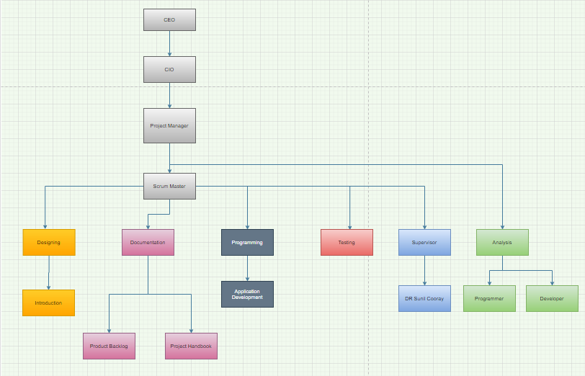

We will be having meetings every week with our client as well as supervisor and will be keeping them updated on the work time to time. The platform chosen for meeting with our client is zoom, as suggested by the client with her feasibility. We have chosen a particular day and time to have a virtual meeting with the client and supervisor and have created a group on whatsapp in case of any changes in the plan.

**2.2 Organizational Structure**

The structure for this is that we will be doing this project in two parts. The initial part which is Sprint 1: this will be the documentation part where we will be analysing and designing the system whereas the second part will be Sprint 2: where we will be developing a Design for the app.

There are three basic roles for scrum:

1.      Product Owner

2.       Scrum Master

3.       Team Member

We have divided the roles among us and will vary each week as everyone will be having an opportunity to show their managerial and leadership skills. This week’s Product Owner and Scrum Master are:

|  |  |
| --- | --- |
| Product Owner | Kamal Pun |
| Scrum Master | Riaz Qadir |

**2.3 Organization Boundaries and Interfaces**

As the project is divided into two parts Sprint 1: (documentation part) and sprint 2: (Design part). In the start things really were not in our favour, Our team was the only team who did not have a meeting with the client for a bit long due to some issues, while the other teams already had their few meetings. But finally we sorted out our issues and had a meeting with a client on zoom video call. This was the first meeting where we had no experience of how to present ourselves in the professional industry but things really went well as the client went happily from us and fixed the date for the next meeting too.

The roles which we have decided till now are the roles of Scrum Master and Product Owner. These two roles will be rotating among team members every week.

Below is the RACI model which tells about the tasks of each stakeholder for this project.

|  |  |
| --- | --- |
| R | RESPONSIBLE |
| A | ACCOUNTABLE |
| C | CONSULTED |
| I | INFORMED |

|  |  |  |  |  |  |  |  |
| --- | --- | --- | --- | --- | --- | --- | --- |
| Tasks | Client | Supervisor | Project Leader | Project Owner | Scrum master | Programmer | Designer |
| Assign project Leader |  | R |  | C | C | C | C |
| Assign Project Owner |  | R | R |  | C | C | C |
| Assign Scrum Master |  | R | R | C |  | C | C |
| Identify Stakeholders | C | C | R |  |  |  |  |
| Identify Main Tasks | I | C | R | A | C | C | C |
| Work Breakdown Structure | I | I | R | A | C | C | C |
| Keeping Track with Deadlines | I | C | R | A | C | C | C |
| Communication Management |  |  | A | C | R | C | C |
| Risk Management |  | I | C | R | C | A | C |
| Quality of work | C | C | R | C | C | A | A |
| Keeping track of team members | I | C | R | A | C | C | C |

The mode of communication chosen by our client and us is, zoom video call where our client will be creating a room and we will be getting the link via email or through whatsapp as preferred by the client. Scrum master will be responsible for the communications as it is the role of the Scrum Master to take care of communications with client and supervisor.

**2.4 Project Responsibilities**

The responsibilities are divided among each of us by their own choice as per their interests towards this project.

|  |  |  |
| --- | --- | --- |
| Stake holders | Represent | Roles |
| Roshan  dhital | Project  Leader | Roshan is The project Leader of our team where he will be looking after the team and work and where needed, he will be guiding us as project leader has got major responsibility of the team. |
| Kamal  pun | Project  Owner | Project owner is the one who will be prioritising the necessary work and has a responsibility for managing the requirements. It is the duty of project owner to finalise the work. |
| Scrum  Master | Riaz  Qadir | Riaz will be looking after the communications with client and supervisor as a scrum master it is his role to keep track of every change is documented and process is followed properly |
| Jasshandeep  Singh | Programmer | Jass is the team member who will be looking after the coding and programing of the app. |
| Muhammad  Haque | Designer | Muhammad will be assisting kamal in overall reports and will be designing the basics of the app. |